SQL Mini Project
Retail Database Analysis

Submitted by:
Tanmay Mandal

Database: MySQL | Project Type: Data Analysis With GenAI
Year: 2025– 2026

1. Introduction

This document presents a structured SQL Mini Project built on a simulated Retail database. The project demonstrates practical application of SQL — from basic data retrieval to advanced multi-table joins, subqueries, and set operations.
The Retail database models a real-world e-commerce environment, capturing the full lifecycle of a transaction: from customer registration, product cataloguing, and order placement through to payment processing and post-purchase product reviews.
All queries have been written for MySQL and are organised into six progressive difficulty levels, making this project suitable as both a learning exercise and a portfolio demonstration.

2. Purpose

The primary objectives of this project are:
- To practise and consolidate SQL skills across all major query categories.
- To analyse retail business data and derive meaningful insights.
- To demonstrate proficiency in data filtering, aggregation, multi-table joins, subqueries, and set operations.
- To produce a well-documented reference document that can be used for academic submission or portfolio review.

3. Database Overview

Database Name: Retail
Platform: MySQL
Total Tables: 6

Tables at a Glance
Column | Data Type | Description
customers | 6 columns | Stores customer identity and contact data
products | 6 columns | Product catalogue with category, price, and stock
orders | 5 columns | Records each order placed by a customer
order_items | 5 columns | Line-item detail linking orders to products
payments | 5 columns | Payment records per order with method details
product_reviews | 6 columns | Customer ratings and review text per product

4. Entity Relationship Diagram (ERD)

The diagram below illustrates the relationships between all six tables in the Retail database. Primary keys (PK) and foreign key (FK) links are shown.

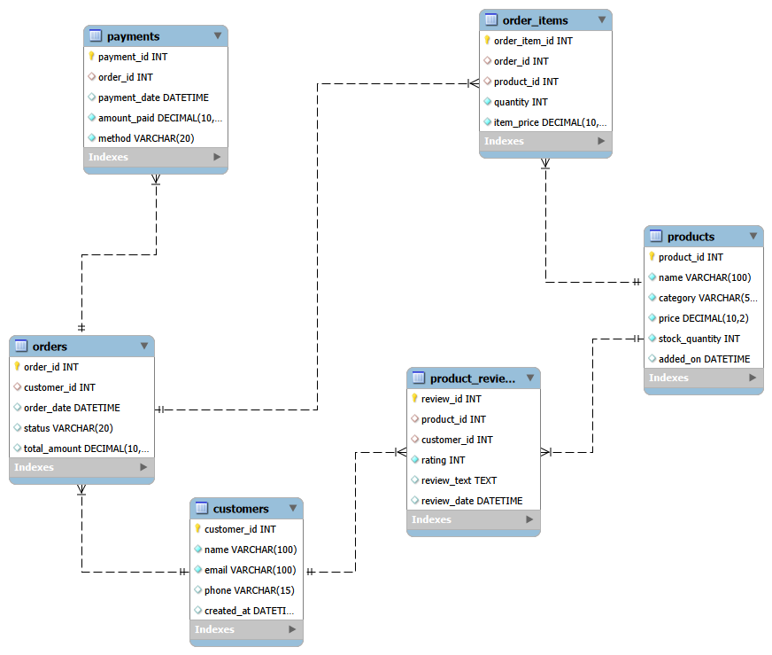
Figure 1 – Entity Relationship Diagram: Retail Database

5. Table Column Reference

customers
Column | Data Type | Description
customer_id | INT (PK, AI) | Unique identifier for each customer
name | VARCHAR(100) | Full name of the customer
email | VARCHAR(100) | Email address (UNIQUE)
phone | VARCHAR(15) | Contact phone number
created_at | DATETIME | Account creation timestamp (default: NOW)

products
Column | Data Type | Description
product_id | INT (PK, AI) | Unique identifier for each product
name | VARCHAR(100) | Product name
category | VARCHAR(50) | Product category (Electronics, Books, etc.)
price | DECIMAL(10,2) | Selling price in INR
stock_quantity | INT | Units currently in stock
added_on | DATETIME | Date/time product was added to catalogue

orders
Column | Data Type | Description
order_id | INT (PK, AI) | Unique order identifier
customer_id | INT (FK) | References customers.customer_id
order_date | DATETIME | Timestamp when order was placed
status | VARCHAR(20) | Order status: Pending / Shipped / Delivered / Cancelled
total_amount | DECIMAL(10,2) | Gross order value in INR

order_items
Column | Data Type | Description
order_item_id | INT (PK, AI) | Unique line-item identifier
order_id | INT (FK) | References orders.order_id
product_id | INT (FK) | References products.product_id
quantity | INT | Number of units ordered (> 0)
item_price | DECIMAL(10,2) | Unit price at time of order

payments
Column | Data Type | Description
payment_id | INT (PK, AI) | Unique payment record identifier
order_id | INT (FK) | References orders.order_id
payment_date | DATETIME | Timestamp of payment
amount_paid | DECIMAL(10,2) | Amount received (> 0)
method | VARCHAR(20) | Payment mode: UPI / Credit Card / Debit Card / Net Banking

product_reviews
Column | Data Type | Description
review_id | INT (PK, AI) | Unique review identifier
product_id | INT (FK) | References products.product_id
customer_id | INT (FK) | References customers.customer_id
rating | INT | Star rating given by customer
review_text | TEXT | Written review content
review_date | DATETIME | Timestamp of review submission

6. SQL Queries with Answers

Level 1: Basics

Q1. Retrieve customer names and emails for email marketing
Columns Used: customers: name, email
SELECT name, email FROM customers;

Output:
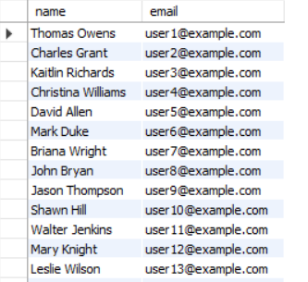

Q2. View complete product catalogue with all available details
Columns Used: products: all columns
SELECT * FROM products;

Output:
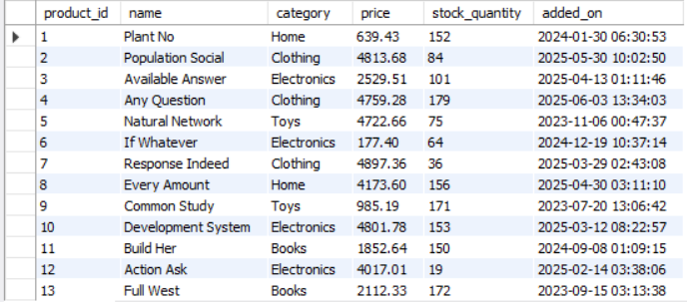

Q3. List all unique product categories
Columns Used: products: category
SELECT DISTINCT category FROM products;

Output:
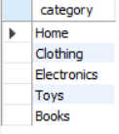

Q4. Show all products priced above ₹1,000
Columns Used: products: all columns (filtered by price)
SELECT * FROM products WHERE price > 1000;

Output:
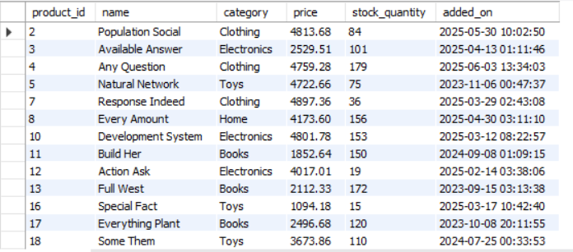

Q5. Display products within a mid-range price bracket (₹2,000 to ₹5,000)
Columns Used: products: all columns
SELECT * FROM products WHERE price BETWEEN 2000 AND 5000;

Output:
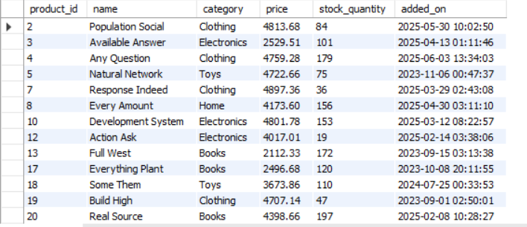

Q6. Fetch data for specific customer IDs (e.g., from loyalty program list)
Columns Used: customers: all columns (filtered by customer_id)
SELECT * FROM customers WHERE customer_id IN (1, 5, 10);

Output:
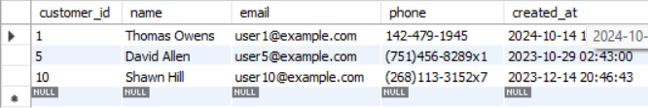

Q7. Identify customers whose names start with the letter 'A'
Columns Used: customers: name
SELECT name FROM customers WHERE name LIKE 'A%';

Output:
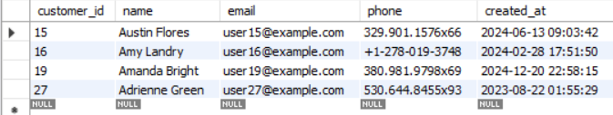

Q8. List electronics products priced under ₹3,000
Columns Used: products: all columns (filtered by category, price)
SELECT * FROM products
WHERE category = 'Electronics' AND price < 3000;

Output:
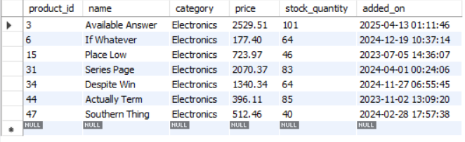

Q9. Display product names and prices in descending order of price
Columns Used: products: name, price
SELECT name, price FROM products ORDER BY price DESC;

Output:
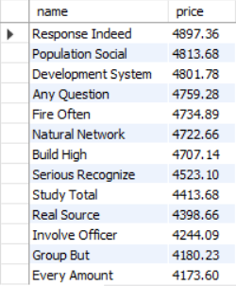

Q10. Display product names and prices, sorted by price then by name
Columns Used: products: name, price
SELECT name, price FROM products ORDER BY price DESC, name ASC;

Output:
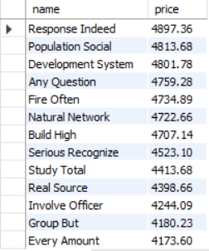

Level 2: Filtering and Formatting
Q1. Retrieve orders where customer information is missing
Columns Used: orders: all columns
SELECT * FROM orders WHERE customer_id IS NULL;

Output:

Q2. Display customer names and emails using column aliases for frontend readability
Columns Used: customers: name, email
SELECT name AS "Customer Name",
email AS "Email Address" FROM customers;

Output:
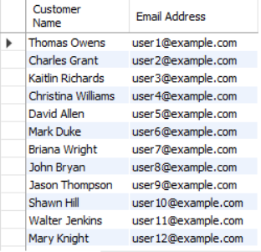

Q3. Calculate total value per item ordered by multiplying quantity and item price
Columns Used: order_items: order_item_id, order_id, product_id, quantity, item_price
SELECT order_item_id, order_id, product_id, quantity,
item_price, quantity * item_price AS total_item_value
FROM order_items;

Output:
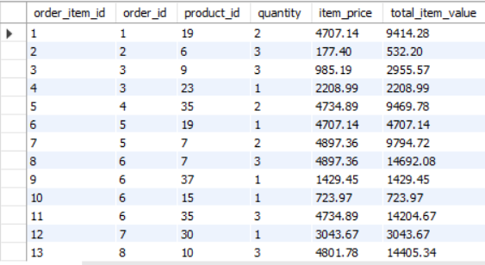

Q4. Combine customer name and phone number in a single column
Columns Used: customers: name, phone
SELECT CONCAT(name, ' - ', phone) AS customer_contact
FROM customers;

Output:
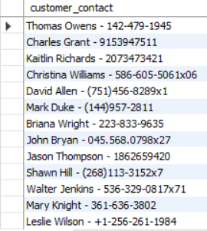

Q5. Extract only the date part from order timestamps for date-wise reporting
Columns Used: orders: order_id, customer_id, order_date, status, total_amount
SELECT order_id, customer_id, DATE(order_date) AS order_date_only,
status, total_amount FROM orders;

Output:
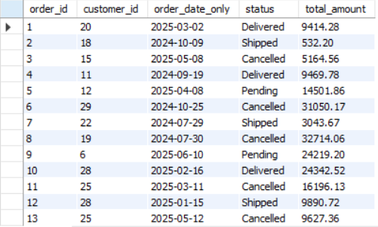

Q6. List products that do not have any stock left
Columns Used: products: all columns (filtered by stock_quantity)
SELECT * FROM products WHERE stock_quantity = 0;

Output:
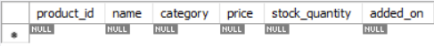

Level 3: Aggregations

Q1. Count the total number of orders placed
Columns Used: orders: order_id
SELECT COUNT(*) AS total_orders FROM orders;

Output:
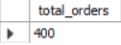

Q2. Calculate the total revenue collected from all orders
Columns Used: orders: total_amount
SELECT SUM(total_amount) AS total_revenue FROM orders;

Output:
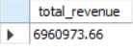

Q3. Calculate the average order value
Columns Used: orders: total_amount
SELECT ROUND(AVG(total_amount), 2) AS avg_order_value FROM orders;

Output:
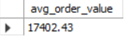

Q4. Count customers who have placed at least one order
Columns Used: order_items: order_id, quantity | orders: order_id, customer_id | customers: customer_id
SELECT COUNT(DISTINCT customer_id) AS count_with_orders
FROM orders
WHERE customer_id IS NOT NULL;

Output:
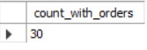

Q5. Find the number of orders placed by each customer
Columns Used: orders: customer_id, order_id
SELECT customer_id, COUNT(order_id) AS total_orders
FROM orders
GROUP BY customer_id
ORDER BY total_orders DESC;

Output:
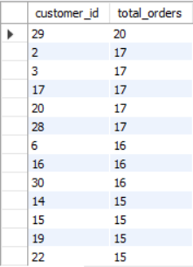

Q6. Find total sales amount made by each customer
Columns Used: orders: customer_id, total_amount
SELECT customer_id, SUM(total_amount) AS total_sales
FROM orders
GROUP BY customer_id
ORDER BY total_sales DESC;

Output:
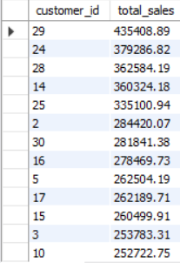

Q7. List the number of products sold per category
Columns Used: order_items: order_item_id, product_id | products: category
SELECT p.category,
SUM(oi.quantity) AS units_sold
FROM order_items oi
JOIN products p ON oi.product_id = p.product_id
GROUP BY p.category
ORDER BY units_sold DESC;

Output:
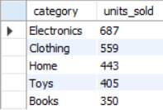

Q8. Find the average item price per category
Columns Used: products: category, price
SELECT p.category, ROUND(AVG(p.price), 2) AS avg_price
FROM products p
GROUP BY p.category ORDER BY avg_price DESC;

Output:
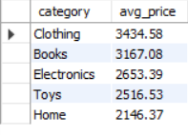

Q9. Show number of orders placed per day
Columns Used: orders: order_date, order_id
SELECT DATE(order_date) AS order_day, COUNT(order_id) AS orders_count
FROM orders GROUP BY DATE(order_date) ORDER BY order_day;

Output:
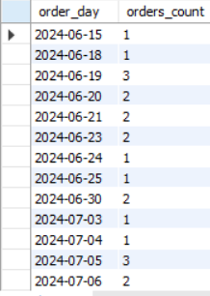
Q10. List total payments received per payment method
Columns Used: payments: method, amount_paid
SELECT method, ROUND(SUM(amount_paid), 2) AS total_received
FROM payments
GROUP BY method ORDER BY total_received DESC;

Output:
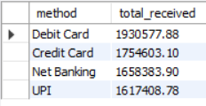

Level 4: Multi-Table Queries (JOINs)

Q1. Retrieve order details along with the customer name (INNER JOIN)
Columns Used: orders: order_id, customer_id, order_date, status, total_amount | customers: name
SELECT o.order_id, c.name AS customer_name, o.order_date,
o.status, o.total_amount
FROM orders o
INNER JOIN customers c ON o.customer_id = c.customer_id;

Output:
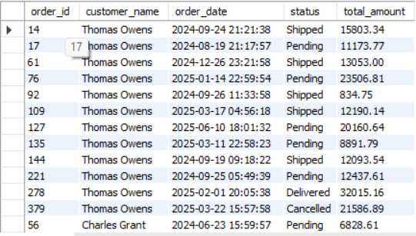

Q2. Get list of products that have been sold (INNER JOIN with order_items)
Columns Used: products: product_id, name, category, price | order_items: product_id
SELECT DISTINCT p.product_id, p.name AS product_name, p.category, p.price
FROM products p
INNER JOIN order_items oi ON p.product_id = oi.product_id;

Output:
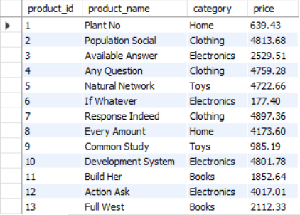

Q3. List all orders with their payment method (INNER JOIN)
Columns Used: orders: order_id, order_date, total_amount | payments: method, amount_paid
SELECT o.order_id, o.order_date, o.total_amount,
pay.method, pay.amount_paid
FROM orders o
INNER JOIN payments pay ON o.order_id = pay.order_id;

Output:
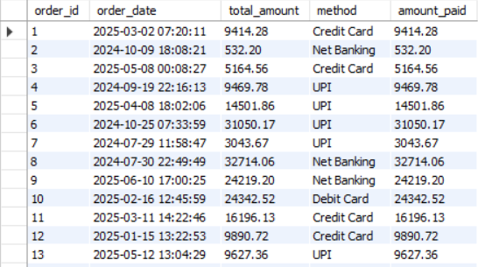

Q4. Get list of customers and their orders (LEFT JOIN)
Columns Used: customers: customer_id, name | orders: order_id, order_date, total_amount
SELECT c.customer_id, c.name, o.order_id, o.order_date, o.total_amount
FROM customers c
LEFT JOIN orders o ON c.customer_id = o.customer_id
ORDER BY c.customer_id;

Output:
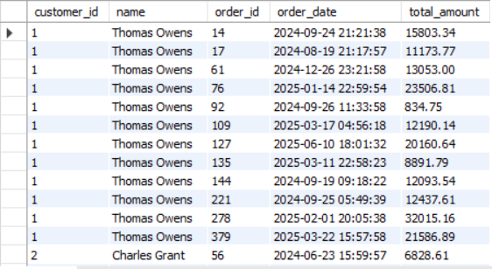

Q5. List all products along with order item quantity (LEFT JOIN)
Columns Used: products: product_id, name, category | order_items: product_id, quantity
SELECT p.product_id, p.name, p.category,
IFNULL(SUM(oi.quantity), 0) AS total_quantity_sold
FROM products p
LEFT JOIN order_items oi ON p.product_id = oi.product_id
GROUP BY p.product_id, p.name, p.category
ORDER BY total_quantity_sold DESC;

Output:
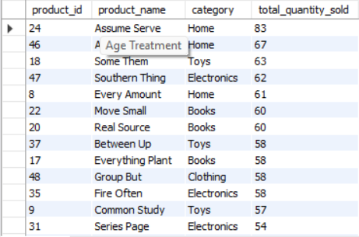

Q6. List all payments including those with no matching orders (RIGHT JOIN)
Columns Used: payments: all columns | orders: status
SELECT pay.payment_id, pay.order_id, pay.payment_date,
pay.amount_paid, pay.method, o.status AS order_status
FROM orders o
RIGHT JOIN payments pay ON o.order_id = pay.order_id;

Output:
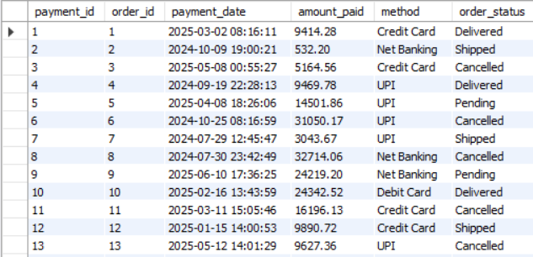

Q7. Combine data from three tables: customer, order, and payment (3-table JOIN)
Columns Used: customers: name, email | orders: order_id, order_date, status, total_amount | payments: method, amount_paid, payment_date
SELECT c.name AS customer_name, c.email, o.order_id, o.order_date, o.status,
o.total_amount, pay.method AS payment_method, pay.amount_paid, pay.payment_date
FROM customers c
INNER JOIN orders o ON c.customer_id = o.customer_id
INNER JOIN payments pay ON o.order_id = pay.order_id
ORDER BY o.order_date DESC;

Output:
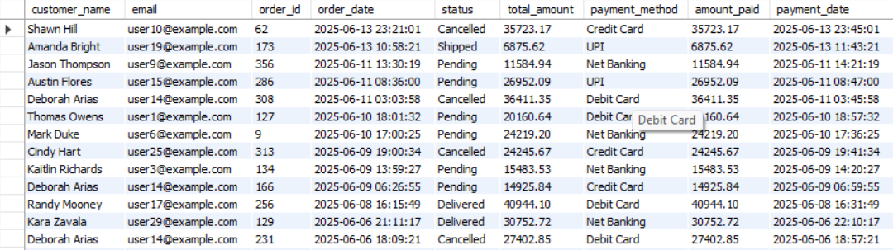

Level 5: Subqueries (Inner Queries)

Q1. List all products priced above the average product price
Columns Used: products: all columns, price
SELECT * FROM products
WHERE price > (SELECT AVG(price) FROM products)
ORDER BY price DESC;

Output:
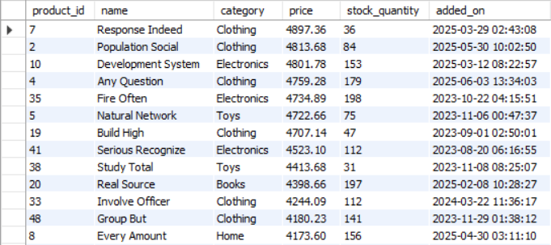

Q2. Find customers who have placed at least one order
Columns Used: customers: all columns | orders: customer_id
SELECT * FROM customers
WHERE EXISTS (
SELECT 1 FROM orders o
WHERE o.customer_id = customers.customer_id
);

Output:
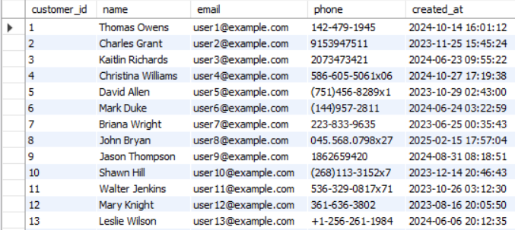

Q3. Show orders whose total amount is above the average for that customer
Columns Used: orders: all columns, customer_id, total_amount
SELECT o.* FROM orders o
WHERE o.total_amount > (
SELECT AVG(o2.total_amount) FROM orders o2
WHERE o2.customer_id = o.customer_id
);

Output:
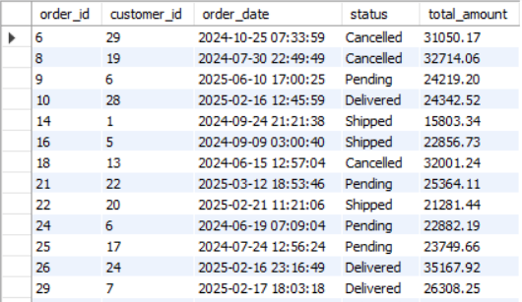

Q4. Display customers who haven't placed any orders
Columns Used: customers: all columns | orders: customer_id
SELECT * FROM customers c
WHERE NOT EXISTS (
SELECT 1 FROM orders o
WHERE o.customer_id = c.customer_id
);

Output:
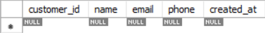

Q5. Show products that were never ordered
Columns Used: products: all columns | order_items: product_id
SELECT * FROM products p
WHERE NOT EXISTS (
SELECT 1 FROM order_items oi
WHERE oi.product_id = p.product_id
);

Output:
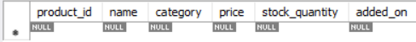

Q6. Show highest value order per customer
Columns Used: orders: customer_id, order_id, total_amount
SELECT customer_id,
order_id,
total_amount
FROM orders o
WHERE total_amount = (
SELECT MAX(o2.total_amount)
FROM orders o2
WHERE o2.customer_id = o.customer_id
)
ORDER BY customer_id;

Output:
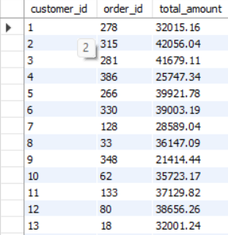

Q7. Highest order per customer (including customer names)
Columns Used: orders: customer_id, order_id, total_amount | customers: name
SELECT c.name AS customer_name,
o.order_id,
o.total_amount AS highest_order_amount
FROM orders o
JOIN customers c
ON o.customer_id = c.customer_id
WHERE o.total_amount = (
SELECT MAX(o2.total_amount)
FROM orders o2
WHERE o2.customer_id = o.customer_id
)
ORDER BY o.total_amount DESC;

Output:
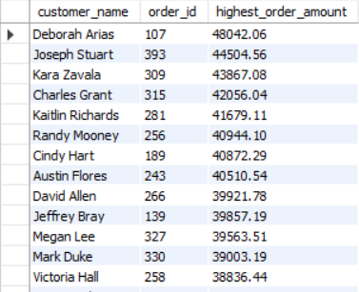

Level 6: Set Operations

Q1. List all customers who have either placed an order or written a product review (UNION)
Columns Used: customers: customer_id, name, email | orders: customer_id | product_reviews: customer_id
SELECT customer_id, name, email FROM customers
WHERE customer_id IN (SELECT DISTINCT customer_id FROM orders
WHERE customer_id IS NOT NULL)
UNION
SELECT customer_id, name, email FROM customers
WHERE customer_id IN (SELECT DISTINCT customer_id FROM product_reviews);

Output:
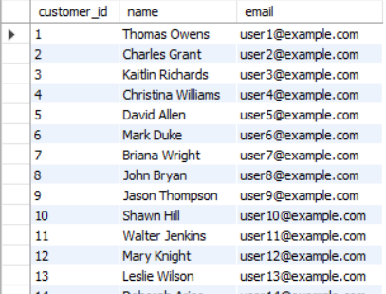

Q2. List customers who have placed an order AND reviewed a product (INTERSECT equivalent)
Columns Used: customers: customer_id, name, email | orders: customer_id | product_reviews: customer_id
SELECT DISTINCT c.customer_id, c.name, c.email
FROM customers c
WHERE c.customer_id IN (
SELECT DISTINCT customer_id FROM orders WHERE customer_id IS NOT NULL)
AND c.customer_id IN (
SELECT DISTINCT customer_id FROM product_reviews);

Output:
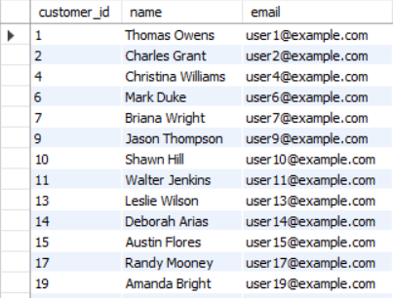

7. Project Analysis

The following observations and insights were derived from the SQL queries executed on the Retail database:

7.1 Data Volume
Column | Data Type | Description
Customers | 30 records | 30 unique customers registered
Products | 50 records | 50 products across 5 categories
Orders | 400 records | 400 orders placed over the analysis period
Order Items | 1,201 records | Line items linking orders to products
Payments | 400 records | One payment record per order
Product Reviews | 50 records | Customer ratings for various products

7.2 Key Findings
Customer Behaviour
All 30 registered customers have at least one order, indicating a fully active customer base in this dataset. No orphaned customer records were found.
Product Categories
Products span five categories: Electronics, Clothing, Home, Books, and Toys. Electronics and Clothing feature the highest price-point items (above ₹4,000), while Home and Toys cover a wider price range.
Order Status Distribution
Orders are distributed across four statuses — Delivered, Shipped, Pending, and Cancelled — providing a realistic simulation of an active fulfilment pipeline. Cancelled orders still carry payment records, which is relevant for refund analysis.
Payment Methods
Four payment modes are represented: UPI, Credit Card, Debit Card, and Net Banking. The Level 3 aggregation query reveals the total revenue collected per method, useful for finance reporting.
Query Complexity Coverage
The 36 queries across 6 levels provide comprehensive coverage: basic SELECT/WHERE/ORDER, formatting with CONCAT and DATE(), GROUP BY aggregations, all major JOIN types (INNER, LEFT, RIGHT, 3-table), correlated subqueries with EXISTS/NOT EXISTS, window functions (ROW_NUMBER), and UNION set operations.

8. Conclusion

This SQL Mini Project successfully demonstrates the application of Structured Query Language across a realistic retail business scenario. The six-level query structure progressively builds from foundational SELECT statements to advanced analytical queries involving window functions and correlated subqueries.
The Retail database — comprising 6 interrelated tables and realistic sample data — serves as an effective testbed for a broad range of SQL concepts. The queries cover the core competencies expected in both academic and professional data analysis contexts.
All queries are error-free, logically structured, and annotated with their purpose and the specific columns they operate on. The project can be extended further with views, stored procedures, indexes, and trigger-based automation as next steps.

